|  |  |  |  |  |  |  |
| --- | --- | --- | --- | --- | --- | --- |
| **Write-up** | **Correctness of Program** | **Documentation of Program** | **Viva** | **Timely Completion** | **Total** | **Dated Sign of Subject Teacher** |
| **4** | **4** | **4** | **4** | **4** | **20** |  |
|  |  |  |  |  |  |

Expected Date of Completion:..................................... Actual Date of Completion:.......................

Group A Assignment No: 1

## Title of the Assignment: Data Wrangling, I

Perform the following operations using Python on any open source dataset (e.g., data.csv) Import all the required Python Libraries.

1. Locate open source data from the web (e.g. [https://www.kaggle.com](https://www.kaggle.com/)).
2. Provide a clear description of the data and its source (i.e., URL of the web site).
3. Load the Dataset into the pandas data frame.
4. Data Preprocessing: check for missing values in the data using pandas insult(), describe() function to get some initial statistics. Provide variable descriptions. Types of variables etc. Check the dimensions of the data frame.
5. Data Formatting and Data Normalization: Summarize the types of variables by checking the data types (i.e., character, numeric, integer, factor, and logical) of the variables in the data set. If variables are not in the correct data type, apply proper type conversions.
6. Turn categorical variables into quantitative variables in Python.

**Objective of the Assignment:** Students should be able to perform thedata wrangling operation using Python on any open source dataset

## Prerequisite:

1. Basic of Python Programming
2. Concept of Data Preprocessing, Data Formatting , Data Normalization and Data Cleaning.

## ---------------------------------------------------------------------------------------------------------------

**Contents for Theory:**

1. **Introduction to Dataset**
2. **Python Libraries for Data Science**
3. **Description of Dataset**
4. **Panda Dataframe functions for load the dataset**
5. **Panda functions for Data Preprocessing**
6. **Panda functions for Data Formatting and Normalization**
7. **Panda Functions for handling categorical variables**

**---------------------------------------------------------------------------------------------------------------**

1. **Introduction to Dataset**

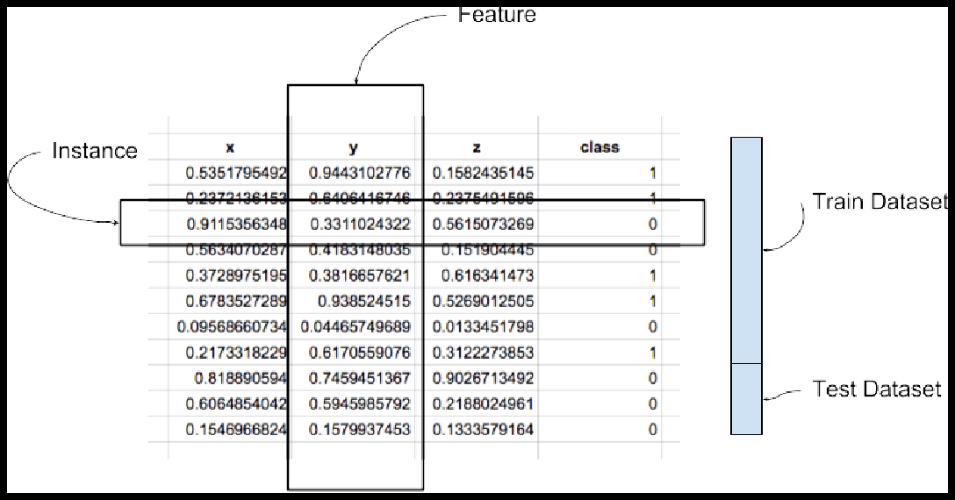A dataset is a collection of records, similar to a relational database table. Records are similar to table rows, but the columns can contain not only strings or numbers, but also nested data structures such as lists, maps, and other records.

**Instance:** A single row of data is called an instance. It is an observation from the domain. **Feature:** A single column of data is called a feature. It is a component of an observation and is also called an attribute of a data instance. Some features may be inputs to a model (the predictors) and others may be outputs or the features to be predicted.

**Data Type**: Features have a data type. They may be real or integer-valued or may have a categorical or ordinal value. You can have strings, dates, times, and more complex types, but typically they are reduced to real or categorical values when working with traditional machine learning methods.

**Datasets**: A collection of instances is a dataset and when working with machine learning methods we typically need a few datasets for different purposes.

**Training Dataset:** A dataset that we feed into our machine learning algorithm to train our model.

**Testing Dataset:** A dataset that we use to validate the accuracy of our model but is not used to train the model. It may be called the validation dataset.

## Data Represented in a Table:

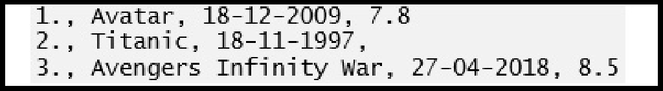Data should be arranged in a two-dimensional space made up of rows and columns. This type of data structure makes it easy to understand the data and pinpoint any problems. An example of some raw data stored as a CSV (comma separated values).

The representation of the same data in a table is as follows:

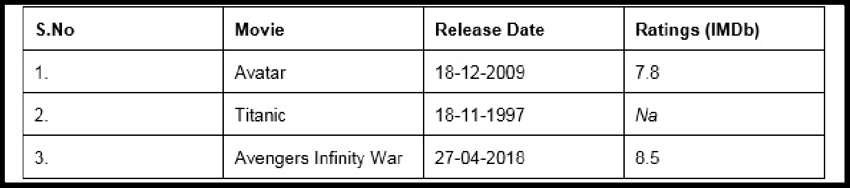

## Pandas Data Types

A data type is essentially an internal construct that a programming language uses to understand how to store and manipulate data.

A possible confusing point about pandas data types is that there is some overlap between pandas, python and numpy. This table summarizes the key points:

|  |  |  |  |
| --- | --- | --- | --- |
| **Pandas dtype** | **Python type** | **NumPy type** | **Usage** |
| object | str or mixed | string_, unicode_, mixed types | Text or mixed numeric and non-numeric values |
| int64 | int | int_, int8, int16, int32, int64, uint8, uint16, uint32, uint64 | Integer numbers |
| float64 | float | float_, float16, float32, float64 | Floating point numbers |
| bool | bool | bool_ | True/False values |
| datetime64 | NA | datetime64[ns] | Date and time values |
| timedelta[ns] | NA | NA | Differences between two datetimes |
| category | NA | NA | Finite list of text values |

## Python Libraries for Data Science

* 1. **Pandas**

Pandas is an open-source Python package that provides high-performance, easy-to-use data structures and data analysis tools for the labeled data in Python programming language.

## What can you do with Pandas?

* + 1. Indexing, manipulating, renaming, sorting, merging data frame
    2. Update, Add, Delete columns from a data frame
    3. Impute missing files, handle missing data or NANs
    4. Plot data with histogram or box plot

## NumPy

One of the most fundamental packages in Python, NumPy is a general-purpose array-processing package. It provides high-performance multidimensional array objects and tools to work with the arrays. NumPy is an efficient container of generic multi-dimensional data.

NumPy’s main object is the homogeneous multidimensional array. It is a table of elements or numbers of the same datatype, indexed by a tuple of positive integers. In NumPy, dimensions are called axes and the number of axes is called rank. NumPy’s array class is called ndarray aka array.

## What can you do with NumPy?

* + 1. Basic array operations: add, multiply, slice, flatten, reshape, index arrays
    2. Advanced array operations: stack arrays, split into sections, broadcast arrays
    3. Work with DateTime or Linear Algebra
    4. Basic Slicing and Advanced Indexing in NumPy Python

## Matplotlib

This is undoubtedly my favorite and a quintessential Python library. You can create stories with the data visualized with Matplotlib. Another library from the SciPy Stack, Matplotlib plots 2D figures.

## What can you do with Matplotlib?

Histogram, bar plots, scatter plots, area plot to pie plot, Matplotlib can depict a wide range of visualizations. With a bit of effort and tint of visualization capabilities, with Matplotlib, you can create just any visualizations:Line plots

* Scatter plots
* Area plots
* Bar charts and Histograms
* Pie charts
* Stem plots
* Contour plots
* Quiver plots
* Spectrograms

Matplotlib also facilitates labels, grids, legends, and some more formatting entities with Matplotlib.

## Seaborn

So when you read the official documentation on Seaborn, it is defined as the data visualization library based on Matplotlib that provides a high-level interface for drawing attractive and informative statistical graphics. Putting it simply, seaborn is an extension of Matplotlib with advanced features.

## What can you do with Seaborn?

* + 1. Determine relationships between multiple variables (correlation)
    2. Observe categorical variables for aggregate statistics
    3. Analyze univariate or bi-variate distributions and compare them between different data subsets
    4. Plot linear regression models for dependent variables
    5. Provide high-level abstractions, multi-plot grids
    6. Seaborn is a great second-hand for R visualization libraries like corrplot and ggplot.

## 5. Scikit Learn

Introduced to the world as a Google Summer of Code project, Scikit Learn is a robust machine learning library for Python. It features ML algorithms like SVMs, random forests, k-means clustering, spectral clustering, mean shift, cross-validation and more... Even NumPy, SciPy and related scientific operations are supported by Scikit Learn with Scikit Learn being a part of the SciPy Stack.

## What can you do with Scikit Learn?

* + 1. Classification: Spam detection, image recognition
    2. Clustering: Drug response, Stock price
    3. Regression: Customer segmentation, Grouping experiment outcomes
    4. Dimensionality reduction: Visualization, Increased efficiency
    5. Model selection: Improved accuracy via parameter tuning
    6. Pre-processing: Preparing input data as a text for processing with machine learning algorithms.

## Description of Dataset:

The Iris dataset was used in R.A. Fisher's classic 1936 paper, The Use of Multiple Measurements in Taxonomic Problems, and can also be found on the UCI Machine Learning Repository.

It includes three iris species with 50 samples each as well as some properties about each flower. One flower species is linearly separable from the other two, but the other two are not linearly separable from each other.

## Total Sample- 150

**The columns in this dataset are:**

* 1. Id
  2. SepalLengthCm
  3. SepalWidthCm
  4. PetalLengthCm
  5. PetalWidthCm
  6. Species

## 3 Different Types of Species each contain 50 Sample-

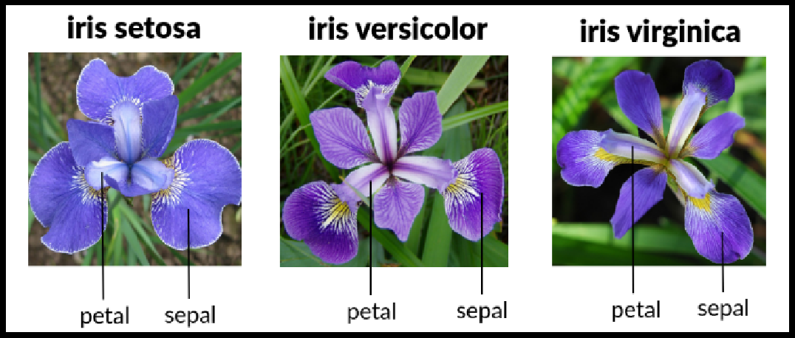

**Description of Dataset-**

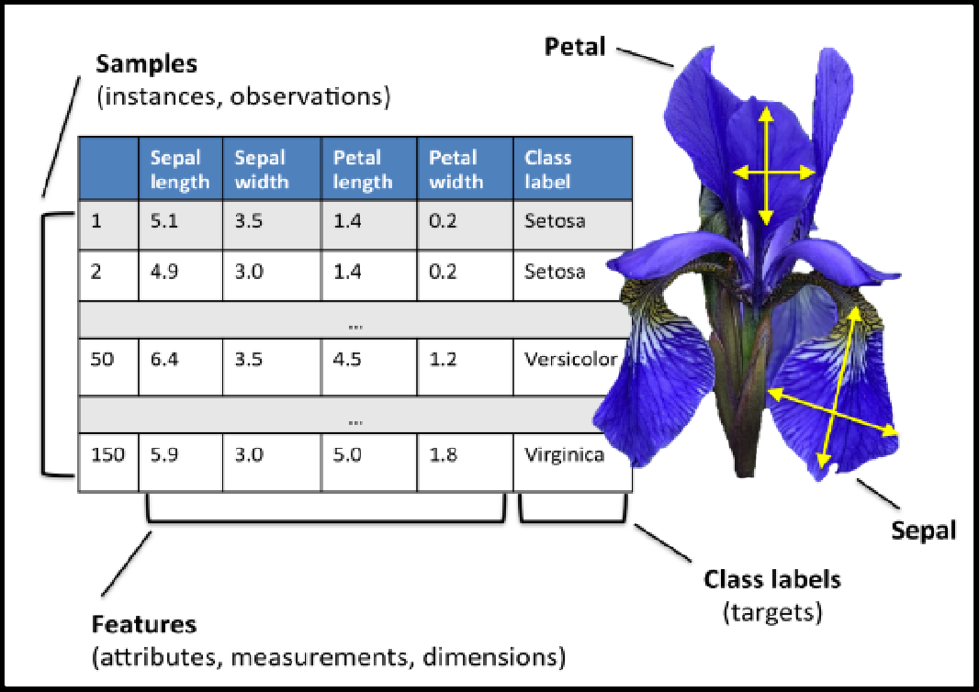

1. **Panda Dataframe functions for Load Dataset**

**# The columns of the resulting DataFrame have different dtypes. iris.dtypes**

1. The dataset is downloads from UCI repository.

## csv_url = 'https://archive.ics.uci.edu/ml/machine-learning-databases/iris/iris.data'

1. Now Read CSV File as a Dataframe in Python from from path where you saved the same The Iris data set is stored in .csv format. ‘.csv’ stands for comma separated values. It is easier to load .csv files in Pandas data frame and perform various analytical operations on it.

Load Iris.csv into a Pandas data frame —

## Syntax-

**iris = pd.read_csv(csv_url, header = None)**

1. The csv file at the UCI repository does not contain the variable/column names. They are located in a separate file.

## col_names = ['Sepal_Length','Sepal_Width','Petal_Length','Petal_Width','Species']

1. read in the dataset from the UCI Machine Learning Repository link and specify column names to use

## iris = pd.read_csv(csv_url, names = col_names)

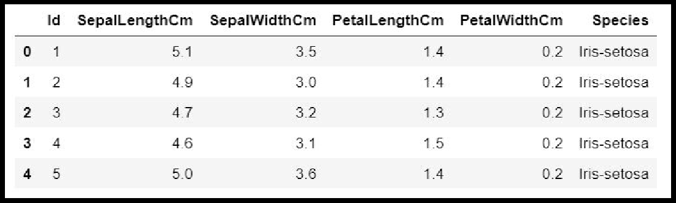

1. **Panda Dataframe functions for Data Preprocessing : Dataframe Operations:**

|  |  |  |
| --- | --- | --- |
| **Sr. No** | **Data Frame Function** | **Description** |
| **1** | **dataset.head(n=5)** | **Return the first n rows.** |
| **2** | **dataset.tail(n=5)** | **Return the last n rows.** |
| **3** | **dataset.index** | The index (row labels) of the Dataset. |
| **4** | **dataset.columns** | The column labels of the Dataset. |
| **5** | **dataset.shape** | Return a tuple representing the dimensionality of the Dataset. |
| **6** | **dataset.dtypes** | Return the dtypes in the Dataset. |

|  |  |  |
| --- | --- | --- |
|  |  | This returns a Series with the data type of each column. The result’s index is the original Dataset’s columns. Columns with mixed types are stored with the object dtype. |
| **7** | **dataset.columns.values** | Return the columns values in the Dataset in array format |
| **8** | **dataset.describe(include='all')** | Generate descriptive statistics.  to view some basic statistical details like percentile, mean, std etc. of a data frame or a series of numeric values.  Analyzes both numeric and object series, as well as Dataset column sets of mixed data types. |
| **9** | **dataset['Column name]** | Read the Data Column wise. |
| **10** | **dataset.sort_index(axis=1, ascending=False)** | Sort object by labels (along an axis). |
| **11** | **dataset.sort_values(by="Colu mn name")** | Sort values by column name. |
| **12** | **dataset.iloc[5]** | Purely integer-location based indexing for selection by position. |
| **13** | **dataset[0:3]** | Selecting via [], which slices the rows. |
| **14** | **dataset.loc[:, ["Col_name1", "col_name2"]]** | Selection by label |

|  |  |  |
| --- | --- | --- |
| **15** | **dataset.iloc[:n, :]** | a subset of the first n rows of the original data |
| **16** | **dataset.iloc[:, :n]** | a subset of the first n columns of the original data |
| **17** | **dataset.iloc[:m, :n]** | a subset of the first m rows and the first n columns |

**Few Examples of iLoc to slice data for iris Dataset**

|  |  |  |  |
| --- | --- | --- | --- |
| **Sr. No** | **Data Frame Function** | **Description** | **Output** |
| **1** | **dataset.iloc[3:5, 0:2]** | Slice the data |  |
| **2** | **dataset.iloc[[1, 2,**  **4], [0, 2]]** | By lists of integer position locations, similar to the NumPy/Python style: |  |
| **3** | **dataset.iloc[1:3, :]** | For slicing rows explicitly: |  |
| **4** | **dataset.iloc[:, 1:3]** | For slicing Column explicitly: |  |

|  |  |  |  |
| --- | --- | --- | --- |
| **4** | **dataset.iloc[1, 1]** | For getting a value explicitly: |  |
| **5** | **dataset['SepalLeng thCm'].iloc[5]** | Accessing Column and Rows by position |  |
| **6** | **cols_2_4=dataset.c olumns[2:4]**  **dataset[cols_2_4]** | Get Column Name then get data from column |  |
| **7** | **dataset[dataset.col umns[2:4]].iloc[5:1 0]** | in one Expression answer for the above two commands |  |

**Checking of Missing Values in Dataset:**

* **isnull()** is the function that is used to check missing values or null values in pandas python.
* isna() function is also used to get the count of missing values of column and row wise count of missing values
* The dataset considered for explanation is:

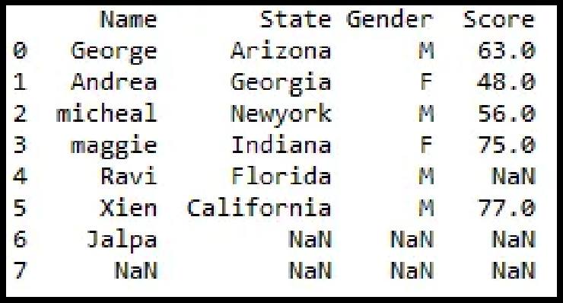

* 1. **is there any missing values in dataframe as a whole**

**Function:** DataFrame.isnull()

**Output:**

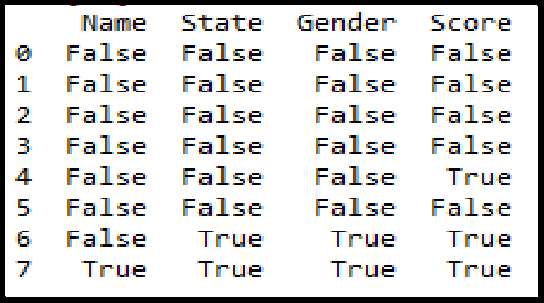

* 1. **is there any missing values across each column Function:** DataFrame**.**isnull().any()

**Output:**

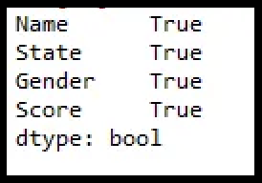

* 1. **count of missing values across each column using isna() and isnull()**

In order to get the count of missing values of the entire dataframe isnull() function is used. sum() which does the column wise sum first and doing another sum() will get the count of missing values of the entire dataframe.

**Function:** dataframe.isnull().sum().sum()

**Output** : 8

* 1. **count row wise missing value using isnull() Function:** dataframe.isnull().sum(axis = 1) **Output:**

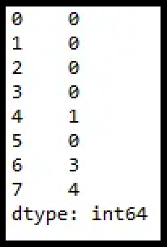

* 1. **count Column wise missing value using isnull() Method 1:**

**Function:** dataframe.isnull().sum()

**Output:**

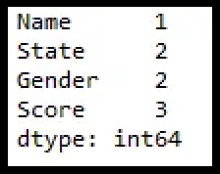

**Method 2:**

**unction:** dataframe.isna().sum()



* 1. **count of missing values of a specific column. Function:**dataframe.col_name.isnull().sum()

# df1.Gender.isnull().sum()

**Output: 2**

* 1. **groupby count of missing values of a column.**

In order to get the count of missing values of the particular column by group in pandas we will be using isnull() and sum() function with apply() and groupby() which performs the group wise count of missing values as shown below.

# **Function:** df1.groupby(['Gender'])['Score'].apply(lambda x: x.isnull().sum())

**Output:**

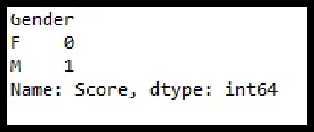

## Panda functions for Data Formatting and Normalization

The Transforming data stage is about converting the data set into a format that can be analyzed or modelled effectively, and there are several techniques for this process.

* 1. **Data Formatting:** Ensuring all data formats are correct (e.g. object, text, floating number, integer, etc.) is another part of this initial ‘cleaning’ process. If you are working with dates in Pandas, they also need to be stored in the exact format to use special date-time functions.

Functions used for data formatting

|  |  |  |  |
| --- | --- | --- | --- |
| **Sr. No** | **Data Frame Function** | **Description** | **Output** |
| 1. | **df.dtypes** | To check the data type |  |
| 2. | **df['petal length (cm)']= df['petal length** | To change the data type (data type of ‘petal length (cm)'changed to int) |  |
|  | **(cm)'].astype("int** |  |
|  | **")** |  |

* 1. **Data normalization:** Mapping all the nominal data values onto a uniform scale (e.g. from 0 to 1) is involved in data normalization. Making the ranges consistent

across variables helps with statistical analysis and ensures better comparisons later on.It is also known as Min-Max scaling.

## Algorithm:

**Step 1 :** Import pandas and sklearn library for preprocessing

from sklearn import preprocessing

**Step 2:** Load the iris dataset in dataframe object df

iris = load_iris()

df = pd.DataFrame(iris.data, columns=iris.feature_names)

**Step 3:** Print iris dataset.

**df.head()**

**Step 4:** Create x, where x the 'scores' column's values as floats

**x = df[['score']].values.astype(*float*)**

**Step 5:** Create a minimum and maximum processor object

**min_max_scaler = preprocessing.MinMaxScaler()**

**Step 6:** Create an object to transform the data to fit minmax processor

**x_scaled = min_max_scaler.fit_transform(x)**

**Step 7:**Run the normalizer on the dataframe

**df_normalized = pd.DataFrame(x_scaled)**

**Step 8:** View the dataframe

**df_normalized**

## Output: After Step 3:

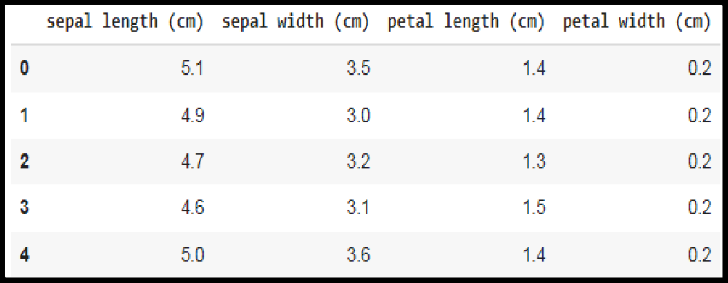

**Output after step 8:**

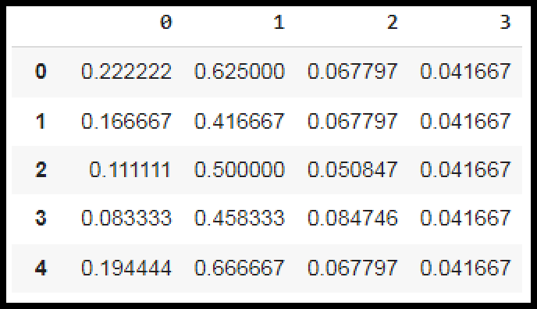

1. **Panda Functions for handling categorical variables**

* **Categorical variables** have values that **describe a ‘quality’ or ‘characteristic’**

of a data unit, like **‘what type’ or ‘which category’.**

* Categorical variables fall into **mutually exclusive (in one category or in another)** and **exhaustive (include all possible options)** categories. Therefore, categorical variables are qualitative variables and t**end to be represented by a non-numeric value.**
* Categorical features refer **to string type data** and can be easily understood by human beings. But in case of a **machine, it cannot interpret the categorical data directly**. Therefore, the categorical data must be **translated into numerical data that can be understood by machine.**

There are many ways to convert categorical data into numerical data. Here the three most used methods are discussed.

1. **Label Encoding:** Label Encoding refers to **converting the labels into a numeric form** so as to convert them into the machine-readable form. **It is an important preprocessing step for the structured dataset** in supervised learning.

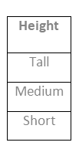**Example :** Suppose we have a column Height in some dataset. After applying label encoding, the Height column is converted into:

SNJB’s Late Sau. K B Jain College of Engineering, Chandwad Dist. Nashik, MS

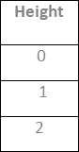

where 0 is the label for tall, 1 is the label for medium, and 2 is a label for short height. **Label Encoding on iris dataset:** For iris dataset the target column which is Species. It contains three species Iris-setosa, Iris-versicolor, Iris-virginica.

## Sklearn Functions for Label Encoding:

* + **preprocessing.LabelEncoder :** It Encode labels with value between 0 and n_classes-1.

## fit_transform(y):

**Parameters:** yarray-like of shape (n_samples,**) Target values.**

**Returns:** yarray-like of shape (n_samples,)

## Encoded labels.

This transformer should be used to encode target values, and not the input.

## Algorithm:

**Step 1 :** Import pandas and sklearn library for preprocessing

from sklearn import preprocessing

**Step 2:** Load the iris dataset in dataframe object df

**Step 3:** Observe the unique values for the Species column.

df['Species'].unique()

**output: array(['Iris-setosa', 'Iris-versicolor', 'Iris-virginica'], dtype=object)**

**Step 4:** define label_encoder object knows how to understand word labels.

label_encoder = preprocessing.LabelEncoder()

**Step 5:** Encode labels in column 'species'.

df['Species']= label_encoder.fit_transform(df['Species'])

**Step 6:** Observe the unique values for the Species column.

## df['Species'].unique()

**Output: array([0, 1, 2], dtype=int64)**

* Use LabelEncoder when there are only two possible values of a categorical feature. For example, features having value such as yes or no. Or, maybe, gender features when there are only two possible values including male or female.

**Limitation:** Label encoding converts the data in machine-readable form, but it assigns a **unique number(starting from 0) to each class of data**. This may lead to the generation of **priority issues in the data sets**. A label with a high value may be considered to have high priority than a label having a lower value.

## One-Hot Encoding:

In one-hot encoding, we create a new set of dummy (binary) variables that is equal to the number of categories (k) in the variable. For example, let’s say we have a categorical variable Color with three categories called “Red”, “Green” and “Blue”, we need to use three dummy variables to encode this variable using one-hot encoding. A dummy (binary) variable just takes the value 0 or 1 to indicate the exclusion or inclusion of a category.

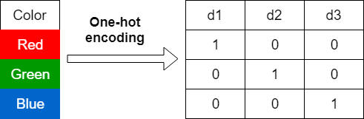

In one-hot encoding,

**“Red”** color is encoded as **[1 0 0]** vector of size 3.

**“Green”** color is encoded as **[0 1 0]** vector of size 3.

**“Blue”** color is encoded as **[0 0 1]** vector of size 3.

**One-hot encoding on iris dataset:** For iris dataset the target column which is Species. It contains three species Iris-setosa, Iris-versicolor, Iris-virginica.

## Sklearn Functions for One-hot Encoding:

* + **sklearn.preprocessing.OneHotEncoder():** Encode categorical integer features using a one-hot aka one-of-K scheme

## Algorithm:

**Step 1 :** Import pandas and sklearn library for preprocessing

from sklearn import preprocessing

**Step 2:** Load the iris dataset in dataframe object df

**Step 3:** Observe the unique values for the Species column.

df['Species'].unique()

**output: array(['Iris-setosa', 'Iris-versicolor', 'Iris-virginica'], dtype=object)**

**Step 4:** Apply label_encoder object for label encoding the Observe the unique

values for the Species column.

## df['Species'].unique()

**Output: array([0, 1, 2], dtype=int64)**

**Step 5:** Remove the target variable from dataset

**features_df=df.drop(columns=['Species'])**

**Step 6:** Apply one_hot encoder for Species column.

enc = preprocessing.OneHotEncoder() enc_df=pd.DataFrame(enc.fit_transform(df[['Species']])).toarray()

**Step 7:** Join the encoded values with Features variable

df_encode = features_df.join(enc_df)

**Step 8**: Observe the merge dataframe

df_encode

**Step 9:** Rename the newly encoded columns.

df_encode.rename(columns = {0:'Iris-Setosa',

1:'Iris-Versicolor',2:'Iris-virginica'}, inplace = True)

**Step 10:** Observe the merge dataframe

df_encode

## Output after Step 8:

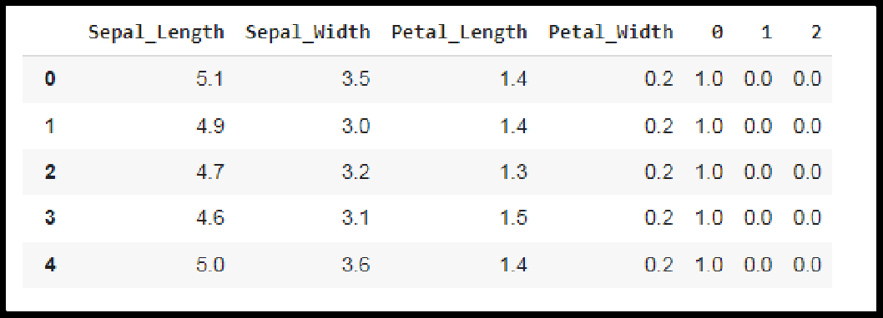

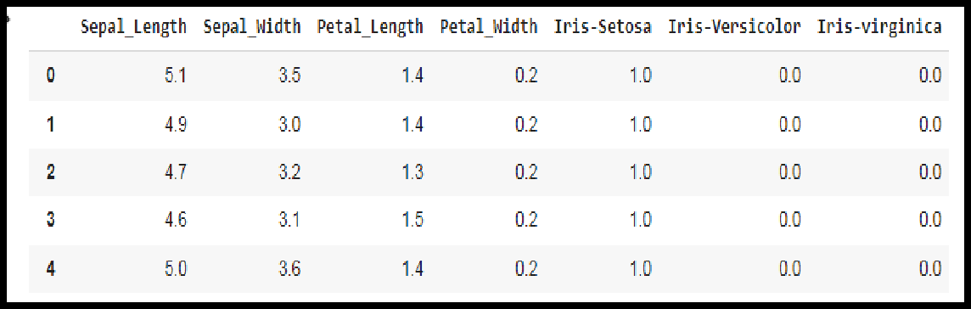**Output after Step 10:**

1. **Dummy Variable Encoding**

Dummy encoding also uses dummy (binary) variables. Instead of creating a number of dummy variables that is equal to the number of categories (k) in the variable, dummy encoding uses k-1 dummy variables. To encode the same Color variable with three categories using the dummy encoding, we need to use only two dummy variables.

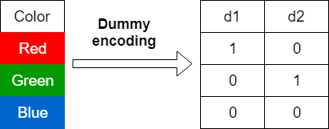

In dummy encoding,

**“Red”** color is encoded as **[1 0]** vector of size 2. **“Green”** color is encoded as **[0 1]** vector of size 2. **“Blue”** color is encoded as **[0 0]** vector of size 2.

Dummy encoding removes a duplicate category present in the one-hot encoding.

## Pandas Functions for One-hot Encoding with dummy variables:

* **pandas.get_dummies(data, prefix=None, prefix_sep='_', dummy_na=False, columns=None, sparse=False, drop_first=False, dtype=None):** Convert categorical variable into dummy/indicator variables.

## Parameters:

**data:**array-like, Series, or DataFrame Data of which to get dummy indicators.

**prefixstr**: list of str, or dict of str, default None String to append DataFrame column names. **prefix_sep**: str, default ‘_’

If appending prefix, separator/delimiter to use. Or pass a list or dictionary as with prefix.

**dummy_nabool:** default False

Add a column to indicate NaNs, if False NaNs are ignored.

**columns:** list:like, default None

Column names in the DataFrame to be encoded. If columns is None then all the columns with object or category dtype will be converted.

## sparse: bool: default False

Whether the dummy-encoded columns should be backed by a SparseArray ( True) or a regular NumPy array (False).

## drop_first:bool, default False

Whether to get k-1 dummies out of k categorical levels by removing the first level.

**dtype**: dtype, default np.uint8

Data type for new columns. Only a single dtype is allowed.

* **Return :** DataFrame with Dummy-coded data.

## Algorithm:

**Step 1 :** Import pandas and sklearn library for preprocessing

from sklearn import preprocessing

**Step 2:** Load the iris dataset in dataframe object df

**Step 3:** Observe the unique values for the Species column.

df['Species'].unique()

**output: array(['Iris-setosa', 'Iris-versicolor', 'Iris-virginica'], dtype=object)**

**Step 4:** Apply label_encoder object for label encoding the Observe the unique

values for the Species column.

df['Species'].unique()

Output: array([0, 1, 2], dtype=int64)

**Step 6:** Apply one_hot encoder with dummy variables for Species column.

one_hot_df = pd.get_dummies(df, prefix="Species", columns=['Species'], drop_first=False)

**Step 7**: Observe the merge dataframe

one_hot_df

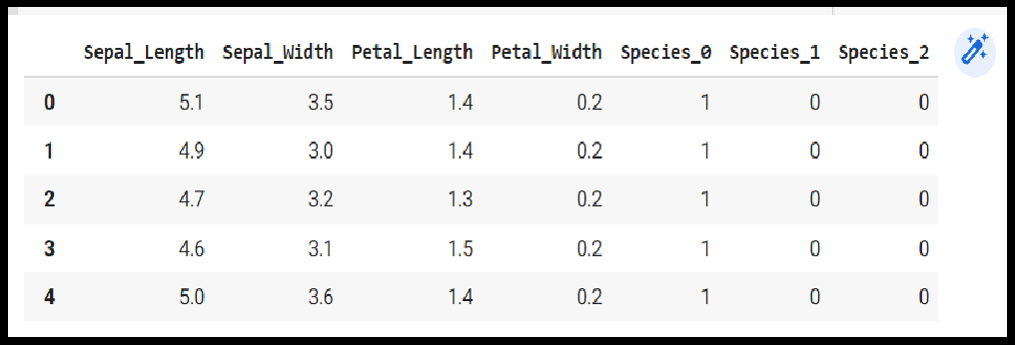

**Conclusion-** In this way we have explored the functions of the python library for Data Preprocessing, Data Wrangling Techniques and How to Handle missing values on Iris Dataset.

## Assignment Question

1. **Explain Data Frame with Suitable example.**
2. **What is the limitation of the label encoding method?**
3. **What is the need of data normalization?**
4. **What are the different Techniques for Handling the Missing Data?**